# **Values Exercise**

**CLARITY**



Why Are Values Important?

The bravest thing you can do is to be yourself. It’s harder than it sounds but for those that aren’t yet there, it’s more transformative than many realise.

Living a life where you keep compromising your values can be toxic, stressful and anxiety inducing. Existing in a world of ‘shoulds’ or by your perceived ideas of what ‘others’ expect is draining, unfulfilling and self-destructive.

It isn’t authentically you and so you can’t expect to perform at your best or be wholly satisfied either. And who wouldn’t want both of those?

An honest appraisal of your values helps you prioritise, gives you focus, aids decision making, keeps you focus and motivated. They become the lenses through which you make sense of your world.

Having Clarity about your values is an integral part of giving you the Confidence and Courage to be the best version of you. Of creating meaningful connection with others from a place of truth.

Bringing our values to consciousness gives us a uniquely powerful tool. Our strength, courage, motivation and purpose will all draw from and be enhanced by aligning to what we do and stand for.

## Your Values Are :-

* Freely chosen
* Ongoing, not fixed like goals
* Guide you rather than constrain
* Are active, not static - can evolve overtime
* Foster self-aceptance
* Bring you freedom from social comparison
* Bring you closer to the person you want to beThe Exercise

From the list below select the values that you feel are most important to you. Those that are most important for you to live by, to be known for, to pass on, to inspire? No judgements. Time for truth.

## The Example

This list is purely to help your thinking, it’s not exhaustive. Add/choose any that are not included in this list, you are looking for YOUR top 10 values. After you have identified values put them in order of importance overleaf. Too many? Look for themes/clusters. Still to many?

|  |  |  |
| --- | --- | --- |
| **Develop enough courage so that you can** | | |
| **stand up for yourself and then stand up** | |  |
|  |  |
| **for somebody else.** |  |

# Maya Angelou

## Values Exercise

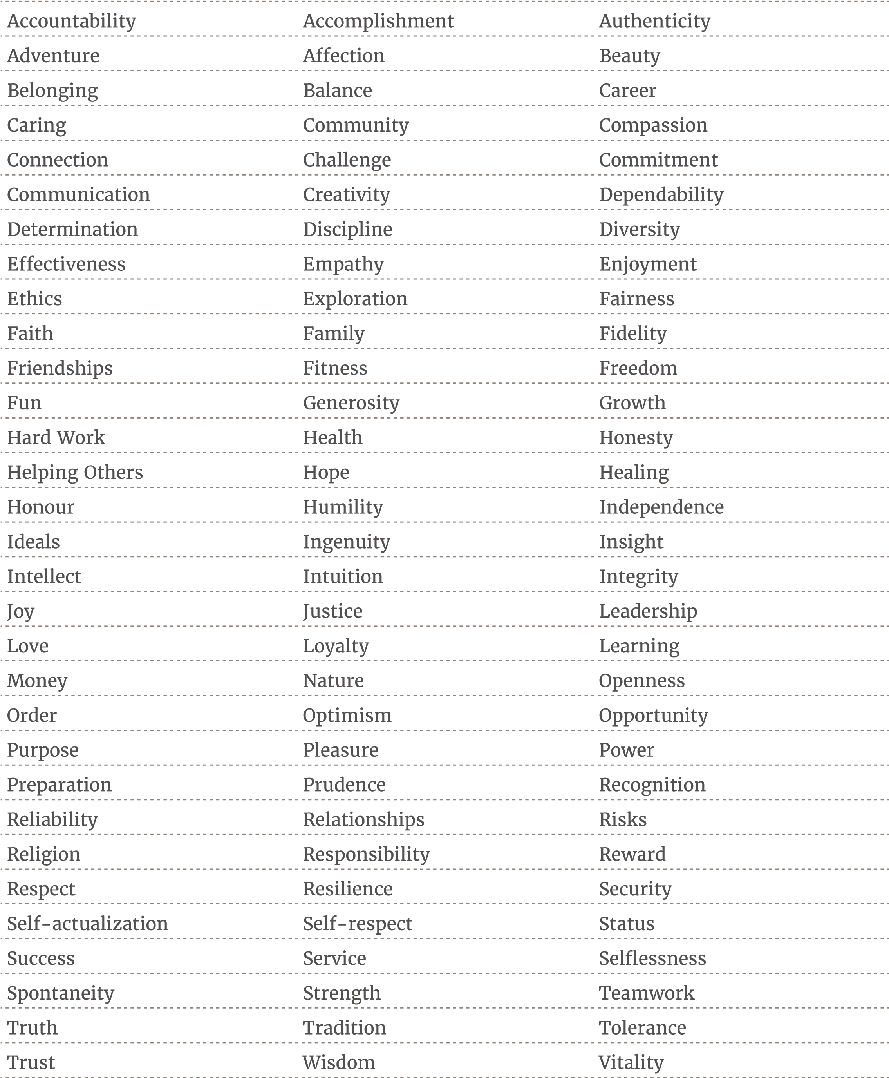

Values Exercise

Then narrow down your list to the 10 most important values and place in order of importance.

Empathy

Resilience

Love

Connection

Trust/ Faith

Authenticity

Discipline/ Determination

Freedom

Learning

Balance

**1**

**2**

**3**

**4**

**5**

**6**

**7**

**8**

**9**

**10**

AAAA

If you could only have one value for the rest of your life which would you pick?

Love can win any battle. It’s the more powerful weapon against any disease.

When you look over this list and reflect on it, what record jumps out to you immediately?

Love

How truly do you think these align with the choices, decisions and behaviours you manifest currently?

I think I align pretty much to all those values. What I need is put more determination or discipline in one or maximum two things at a time. I need to concentrate to avoid losing time in overthinking.

To what extent would you say you are living truthfully an authentically aligned to these? What isn’t aligned as well as it could be? What would it look like if you were more authentically aligned?

Freedom: I am not completely free because I am afraid of the consequences.

If I had a mind free of my insecurities, I would be unstoppable.

In what way is this in congruence with the life you are living now?

I’m a lonely person so I don’t get much physical love.

I try to express affection and love in other ways, like dancing, or chatting with friends, spending time with them.

I think the rest is pretty much congruent with my life now.

## Values Wheel

Transfer each of your values on to the Values Wheel. As you did with the Be Braver Model mark out of 10 how in tune and aligned you think you currently are with each value.

Mark what target you would like to give yourself for each and begin to consider what needs to change to create the shifts.

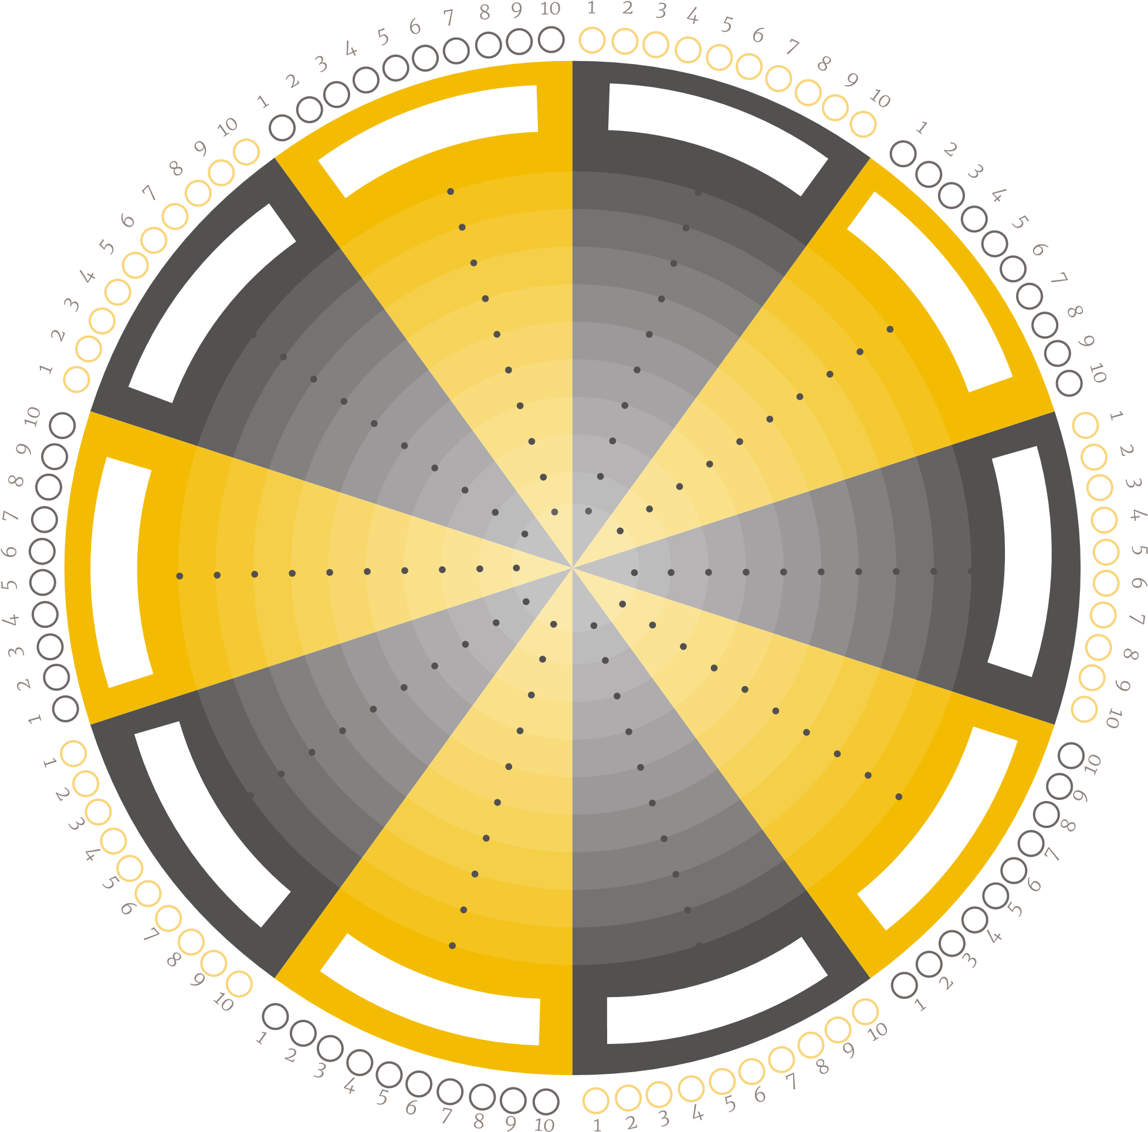

Balance: 6

Freedom: 6

Learning: 8

Discipline/ Determination: 6

Authenticity : 7

Connection: 5

Trust: 5

Resilience: 8

Empathy: 8

Love : 6

**VISION**

**CLARITY**



Be patient, do not loose determination and being disciplined. I need to be brave and look for the people I know can help me to find what I need.

Educate people about how important their individual choices are when they are consuming. Shopping, eating,

leisuring and the global impact it does have.

I am very, very, very faithful and loyal to the ideals I have set up for me in life since I was at least 12 years old.

I am with the right company or dancing.

Creativity. I have an infinite mind capable of relate diverse and difficult concepts or emotions in a single and simple expression, sentence or drawing.

I do want to share who I am with someone else and leave a legacy in this world.

Being authentic, creative, caring, funny and brave. I want people be grateful for having me in their lives.

Creating my own family and do not ever forget them.

My fearless ambition is:

Realising this would be incredible because:

My unique superpowers are:

The bravest thing I have ever done showed

me that:

When I look back on my business/career/life

I want to be remembered by:

It is non-negotiable for me that to make the

first step towards this future I must:

I am in flow when I am:

The problem I most want to solve in the

world is:

**Reflection & insights to treasure forever**

